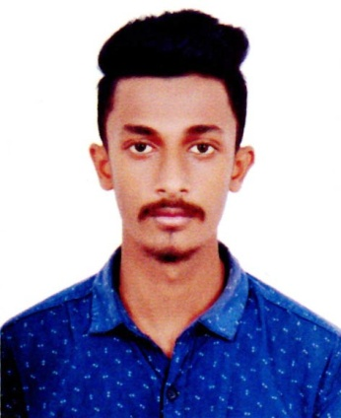
Resume

Of
Rifat Rahman
Call:01757104908
E-mail: rifatrahman508@gmail.com

OBJECTIVE:
To pursuer a challenging career in dynamic organization where I will have the opportunity to utilize my knowledge an prove my skills for professional career development.

EDUCATIONAL QULIFICATION:
Bachelor of Arts (B.A)

Institution : Doctor maleka university college
Passing Year : 2nd Year Running
Group : Humanities
University : National University

Higher Secondary Certificate (H.S.C)

Institution : Doctor maleka university college
Passing Year : 2019
G.PA : 3.17
Group : Humanities
Board : Dhaka

Secondary School Certificate (S.S.C)

Institution : Rajdhani. High School
Passing Year : 2017
G.PA : 4.00
Group : Humanities
Board : Dhaka

LANGUAGE PROFICIENCY :
1. Bangla : Fluent in both spoken and written.
2. English : Fairly in both spoken and written.

EXPERINCE
1. The popeyes (Fast Food & Cold Coffe)
2. Daly Seaso (Fast Food & Cold Coffe)
3. Apex
4. Lotto

PERSONAL INFORMATION :
Name : Md Rifat Rahman
Father’s Name : Md Habibullah Khokon
Mother’s Name : Most. Nazma Akter
Present Address : House No-401, SP Road, Kallyanpur
Mirpur, Dhaka-1207.
Permanent Address : House# 41/1/B, Babor Road, Johuri Moholla, Mohammadpur, Dhaka.
Date of Birth : 05-10-1998
Nationality : Bangladeshi
Religion : Islam
Marital Status : Unmarried
Sex : Male
Height : 5'7"

Signature

…………………..
Md. Rifat Rahman

