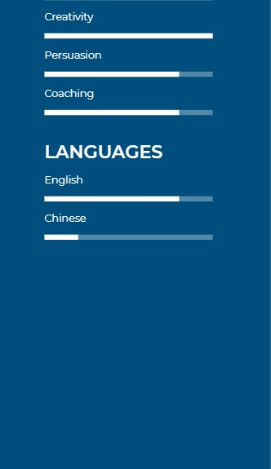
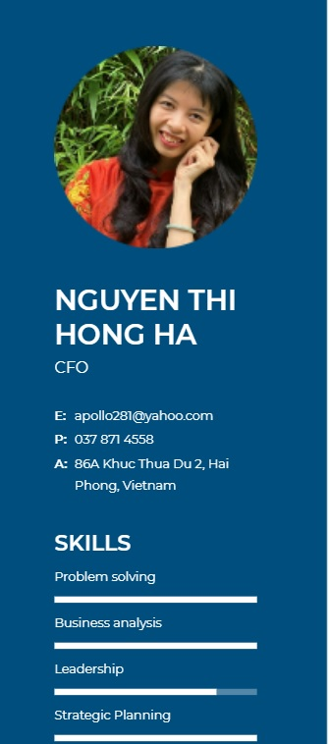
PROFILE

An unstopped learning professional person in Finance field who looks for a job with challenges in order to utilize all experiences and skills

EDUCATION
. Master of Science in International Business I Brunel University, London, UK
September 2008 – January 2010
. Bachelor of Commerce in External Economics I Foreign Trade University, Hanoi, Vietnam
September 2003 – May 2008

EXPERIENCE
Chief Financial Officer @ AMECC Mechanical Construction JSC, Haiphong, Vietnam
November 2020 – April 2021
Responsibilities:
. Using financial data to challenge the business, link strategic objectives with the financial goal of the business and contribute to operational decision making of CEO and chairman related to investment projects, business targets and business strategy.
. Managing the processes for financial forecasting and budgets, cash flow via overseeing all business activities related to Receivables and Payables, income and outcome cash flows, cutting costs and utilizing the efficiency of financial expenses in order to maintaining the necessary working capital
. Building the strategy to improve the financial system and in-charge of all financial reports to BOD, shareholders, partners and functional organizations like State Securities commission, Tax department, etc.
. Controlling risks in term of legal status of subsidiaries and partners including re-structuring company’s organization; protecting company’s benefits in all deals and implementing risk management tools in business activities.
Achievement:
. Save the company from the working capital lack situation by balancing working capital and applying financial tools to
. Reduce the loan interest rate down by 3 to 5% for current and new loans, decrease the company’s loan by a third after 4 months
. Reduce a third of company’s loans by sorting out the overdue loans like salary, CIT, etc. and push up the cash-in flow from customers.
Finance Consultant @ New World Fashion Group, Haiphong, Vietnam
November 2014 – October 2020
Responsibilities:
- At Group level:
. In-charge of Hermes project to build up and improve the corporate governance, modify HR policies for top management of the Group and restructure the Group’s organization.
. Provides financial management information by performing financial status analyses to support business development planning. Prepare and submit monthly financial reports to chairman.
. Participate in budget preparation activities, evaluating risk tolerance and establish financial goals, matching goals to situation with appropriate financial plans to increase profitability.
. Build healthy and long term relationships with clients and all business partners.
. Updates and maintain the in-depth knowledge of financial strategies and products by tracking financial markets, general economic conditions, and new financial products; reading professional and technical publications; maintaining personal networks and following the latest Act/Agreement/Rules of international Committee/Organization
. Analyse market trends and the economic policies of some tax-heaven countries in order to identify risks and opportunities for restructuring the Group in order to utilize current and future tax payments
. Manage a team to monitor and control all expenses of some offices within the allotted budget and Group account receivables team.

- At Group’s subsidiaries outside Vietnam
. In-charge of Accounting division, auditing and tax declaration for subsidiaries in United Kingdom including New World Clothing limited, London Wholesale limited and Hainault Golf Club limited.
. Establishing the subsidiaries in HongKong and managing their cash-flow directly
. Controlling financial activities and relationships to customers and banks of subsidiaries in Singapore
. Reviewing and controlling the legal status of company in British Virgin Islands
- At Group’s subsidiaries inside Vietnam
. Consulting factories in Vietnam for all tax issues such as Transferring price, loan interests among affiliates, etc
. Auditing factories’ reports and controlling their budget performance
. Reviewing the factories’ performance yearly
Achievement:
. Restructure the Group’s organization in global scale for tax utilization.
. Set up and maintain the affiliates in Hong Kong, Singapore and BVI
. Obtain the best deals for Group from international banks like Standard Charter, UOB, HSBC in term of interest rate and fee.
. Represent the Group to negotiate deals with partners like investors, financial funds, consulting agencies, etc.
Audit Assistant @ KPMG Limited, Hanoi, Vietnam
September 2012 – September 2014
Responsibilities:

. Examination with the results of previous audits, in order to understand the processes that are specific for a particular client.
. Reconciliation of account balances with credit institutions in the accounting client with the data bank.
. Auditing accounts in balance sheet including receivables, payables, long term loan, short term loan, fixed assets, etc.
. Auditing accounts in Profit/loss including revenue, COGs, expenses, CIT, etc.
. Testing of existing processes and controls.
. Maintain the relationship with clients and support clients during the year.
Sale Manager @ New World Clothing limited, London, UK
June 2009 – January 2012
Responsibilities:
. Analyse customer’s models and trend to consult them about products/design in order to build and maintain strong, long-lasting customer relationship.
. Working closely with HR department to prepare Group’s profile to send to new clients before preparing, negotiating and signing the frame contract with them, specific to Carrefour, JDWilliams and JCPenny customers
. To be the main contact between customers and factories for their product’s quality and processing, and suppliers for sourcing the low cost but high quality materials.
. Preparing sale costing, agreeing timescales and budgets, ensure the timely and successful delivery of solutions according to customers ‘needs and objectives.
. Building up the working procedure, recruiting, organizing, allocating, managing, supervising and supporting team to make sure the on time and high quality tasks.
. Writing reports and analysing, interpreting and presenting sale results
. Financial and team administration

REFERENCE
Available upon request

